FAST FACTS AND CONCEPTS #326
ILLNESS TRAJECTORIES: DESCRIPTION AND CLINICAL USE
Paige Comstock Barker, MD and Jennifer S. Scherer, MD

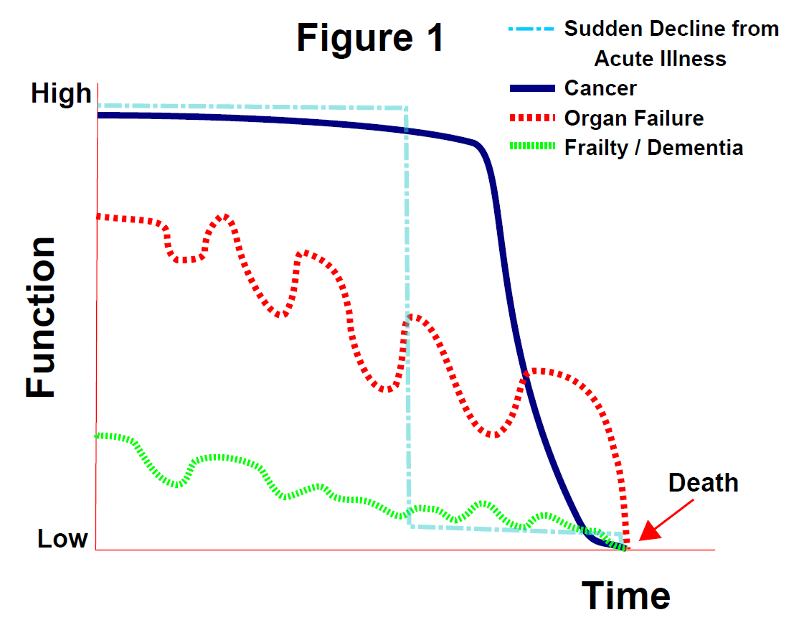
Illness trajectories can provide a framework for addressing patient and family expectations of what will happen with regards to their anticipated health. Distinct illness trajectories have been recognized in the medical literature (see Figure 1). This Fast Fact will review the medical evidence of these trajectories as well as their utility as a patient teaching tool.

General Evidence: A large observational study, described distinct illness trajectories at the end of life for frailty/dementia, cancer, and organ failure (1). Subsequent research has cast some controversy about the validity of these findings, particularly whether hospitalizations may have a more significant role on the pattern of decline than the specific illness itself (2-4).

Illness Trajectories:
Frailty / Dementia: A pattern of dwindling cognitive and/or physical disability that may progress over several years (1). Seventy percent of dementia patients require assistance in ≥3 ADLs, in the last year of life, making these patients at heightened risk for nursing home placement and caregiver breakdown (2). Many clinicians and families may not recognize that dementia by itself is a terminal illness.

Cancer: A relatively stable period of physical function followed by an acute decline in the last few months of life. Multiple studies have supported this trajectory however, the timing of steep decline ranges between 1 to 5 months before death depending on the study (1,5-7). Cancer patients may also experience more predictable patterns of spiritual distress with peaks at diagnosis, disease recurrence, and the terminal phase of illness (8). Because the physical decline and psycho-spiritual distress can be better anticipated, especially in solid tumors, more accurate prognostication and implementation of specialized palliative care services can occur. One study of Medicare patients showed that cancer patients were more likely to utilize hospice in comparison to other chronic illnesses because of the more predictable trajectory (9). More research is needed to validate this trajectory in the face of new targeted treatment modalities.

Organ failure: A more erratic trajectory with punctuated periods of decline likely correlating with acute exacerbations (1). Each exacerbation may result in death but is often survived with gradual deterioration in health and functional status. Timing of death is less certain than in cancer. Perhaps as a result, patients with congestive heart failure (CHF) and chronic obstructive pulmonary disorder are more likely to die in the hospital and less likely to receive hospice services nor understand the likely progression of their illness (9-12). Other take home points regarding the organ failure trajectory include:
- The functional decline for CHF has been shown to be particularly heterogeneous (2,13). Some hypothesize this may be related to co-morbidities and/or research methodologies (13).
- Often prognosis is more centered around patient specific goals regarding acceptance or not of repeat hospitalizations and treatment of potentially reversible complications.
- Although observational studies have shown inconsistent findings, elderly end stage renal disease patients who forgo initiating hemodialysis may be more likely to have an illness trajectory similar to sudden death – stable function for months with a rapid end of life deterioration (14-16).

Sudden Death or Decline: An abrupt change from normal physical function to either death or significant medical disability, often as a result of trauma or an acute cardiopulmonary/neurologic event. Many times there is little or no prior interaction with the health system nor a recognizable pattern of functional decline preceding the event (1,9). Thus, intense displays of shock or anger are common from family members when clinicians break bad news. See Fast Fact #305. Loved ones are at increased risk for depression and complicated grief as they adjust to the new medical reality after the event (17,18).

Clinical Use: Although there is no known published data assessing the effectiveness of utilizing the illness trajectories as a clinical teaching tool, describing or even diagramming these illness trajectories with patients and families may be a concise communication technique to set expectations and offer guidance regarding the anticipated impact of chronic illness on daily life. Clinicians should be aware of the significant variability in the medical literature regarding the validity of these illness trajectories as well as the limitations in the way functional decline is measured between studies. Therefore, it is vital that illness trajectories be reevaluated as the condition evolves. In particular, certain patterns such as an abrupt functional decline or frequent hospitalizations may indicate the need to readdress goals of care.

References:
- Lunney JR, Lynn J, Foley D, et al; Patterns of Functional Decline at the End of Life. JAMA. 2003;289(18): 2387-2392.
- Gill TM, Gahbauer EA, Han L, et al; Trajectories of Disability in the Last Year of Life. The New England Journal of Medicine. 2010;362(13): 1173-1180.
- Gill TM, Gahbauer EA, Han L, et al; The role of intervening hospital admission on trajectories of disability in the last year of life: prospective cohort study of older people. BMJ. 2015;350:1-8.
- Steinhauser KE, Arnold RM, Olsen MK, et al. Comparing Three Life-Limiting Diseases: Does Diagnosis Matter or Is Sick, Sick? J Pain Symptom Manage. 2011; 42(3): 331-341.
- Seow, H, Barbera L, Sutradhar R, et al. Trajectory of Performance Status and Symptom Scores for Patients With Cancer During the Last Six Months of Life. Journal of Oncology. 2011; 29(9): 1151 – 1158.
- Tang ST, Liu LN, Lin KC, et al; Trajectories of the Multidimensional Dying Experience for Terminally Ill Cancer Patients. Journal of Pain and Symptom Management. 2014;48(5): 863-874.
- Teno JM, Weitzen S, Fennell ML, et al. Dying Trajectory in the Last Year of Life: Does Cancer Trajectory Fit Other Diseases? Journal of Palliative Medicine. 2001; 4(4): 457 – 464.
- Murray SA, Kendall M, Grant E, et al; Patterns of Social, Psychological, and Spiritual Decline Toward the End of Life in Lung Cancer and Heart Failure. Journal of Pain and Symptom Management. 2007;34(4): 393-402.
- Lunney JR, Lynn J, Hogan C. Profiles of Older Medicare Decendents. JAGS. 2002;50:1108-1112.
- Gavazzi, A, De Maria R, Manzoli L, et al. Palliative needs for heart failure or chronic obstructive pulmonary disease: Results of a multicenter observational registry. International Journal of Cardiology. 2015;184: 552-558.
- Kendall M, Carduff E, Lloyd A, et al; Different Experiences and Goals in Different Advanced Diseases: Comparing Serial Interviews With Patients With Cancer, Organ Failure, or Frailty and Their Family and Professional Carers. Journal of Pain and Symptom Management. 2015;50(2): 216-224.
- Levenson JW, McCarthy EP, Lynn J, et al; The Last Six Months of Life for Patients with Congestive Heart Failure. JAGS. 2000;48(5): S101-S109.
- Kheribek RE, Alemi F, Citron BA, et al; Trajectory of Illness for Patients with Congestive Heart Failure. Journal of Palliative Medicine. 2013;16(5): 478-484.
- Murtagh, FEM, Addington-Hall J, and Higginson IJ. End-Stage Renal Disease: A New Trajectory of Functional Decline in the Last Year of Life. JAGS. 2011; 59: 304-308.
- Schell JO, Da Silva-Gane M, and Germain MJ. Recent insights into life expectancy with and without dialysis. Current Opin Nephrol Hypertens. 2013;22: 185-192.
- Schell JO and O’Hare AM. Illness trajectories and their relevance to the care of adults with kidney disease. Current Opin Nephrol Hypertens. 2013;22: 316-324.
- Burton, AM, Haley WE, Small BJ. Bereavement after caregiving or unexpected death: Effects on elderly spouses. Aging and Mental Health. 2006;10(3): 319-326.
- Kristensen, P, Weisaeth L, Heir T. Bereavement and Mental Health after Sudden and Violent Losses: A Review. Psychiatry. 2012;75(1):76-97.

Author’s Affiliations: New York University, New York, NY
Conflicts of Interest: None
Version History: Originally edited by Sean Marks MD; first electronically published in December 2016.

Fast Facts and Concepts are edited by Sean Marks MD (Medical College of Wisconsin) and associate editor Drew A Rosielle MD (University of Minnesota Medical School), with the generous support of a volunteer peer-review editorial board, and are made available online by the Palliative Care Network of Wisconsin (PCNOW); the authors of each individual Fast Fact are solely responsible for that Fast Fact’s content. The full set of Fast Facts are available at Palliative Care Network of Wisconsin with contact information, and how to reference Fast Facts.
Copyright: All Fast Facts and Concepts are published under a Creative Commons Attribution-NonCommercial 4.0 International Copyright (http://creativecommons.org/licenses/by-nc/4.0/). Fast Facts can only be copied and distributed for non-commercial, educational purposes. If you adapt or distribute a Fast Fact, let us know!
Disclaimer: Fast Facts and Concepts provide educational information for health care professionals. This information is not medical advice. Fast Facts are not continually updated, and new safety information may emerge after a Fast Fact is published. Health care providers should always exercise their own independent clinical judgment and consult other relevant and up-to-date experts and resources. Some Fast Facts cite the use of a product in a dosage, for an indication, or in a manner other than that recommended in the product labeling. Accordingly, the official prescribing information should be consulted before any such product is used.

